Oracle database concepts

A database schema is a logical container for data structures, called schema objects. Examples of schema objects are tables and indexes

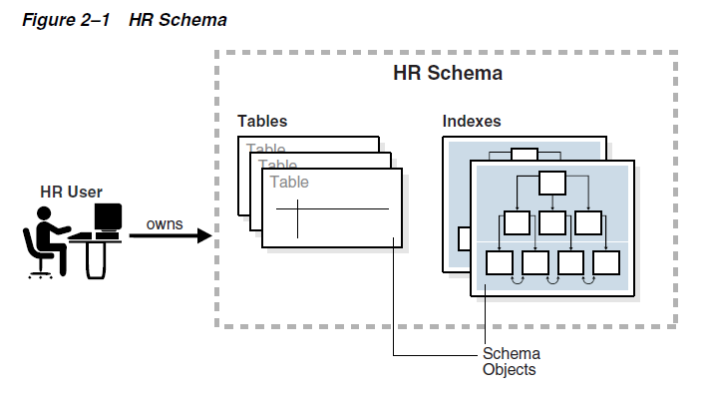

The most important schema objects in a relational database are tables. A table stores data in rows.
Oracle SQL enables you to create and manipulate many other types of schema objects, including the following: Indexes, Views, Sequences, Synonyms, PL/SQL subprograms etc.

Some schema objects store data in logical storage structures called segments. For example, a nonpartitioned heap-organized table or an index creates a segment. Other schema objects, such as views and sequences, consist of metadata only.

At the operating system level, Oracle Database stores database data in data files. For ease of administration, Oracle Database allocates space for user data in tablespaces, which like segments are logical storage structures. Each segment belongs to only one tablespace. For example, the data for a nonpartitioned table is stored in a single segment, which in turn is stored in one tablespace.

A permanent tablespace contains persistent schema objects. Objects in permanent tablespaces are stored in data files. A temporary tablespace contains schema objects only for the duration of a session.
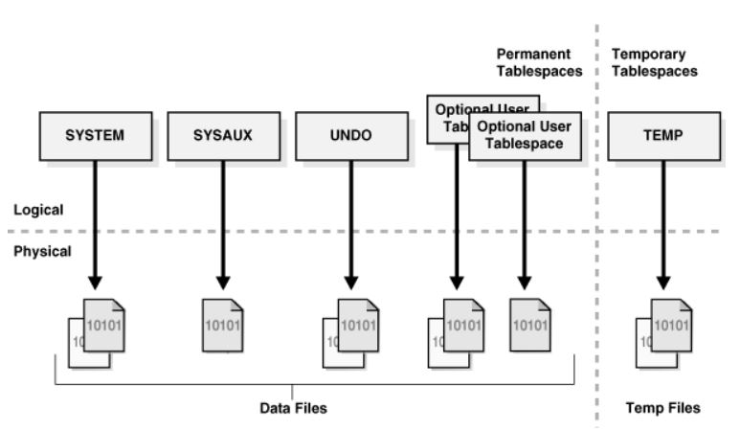
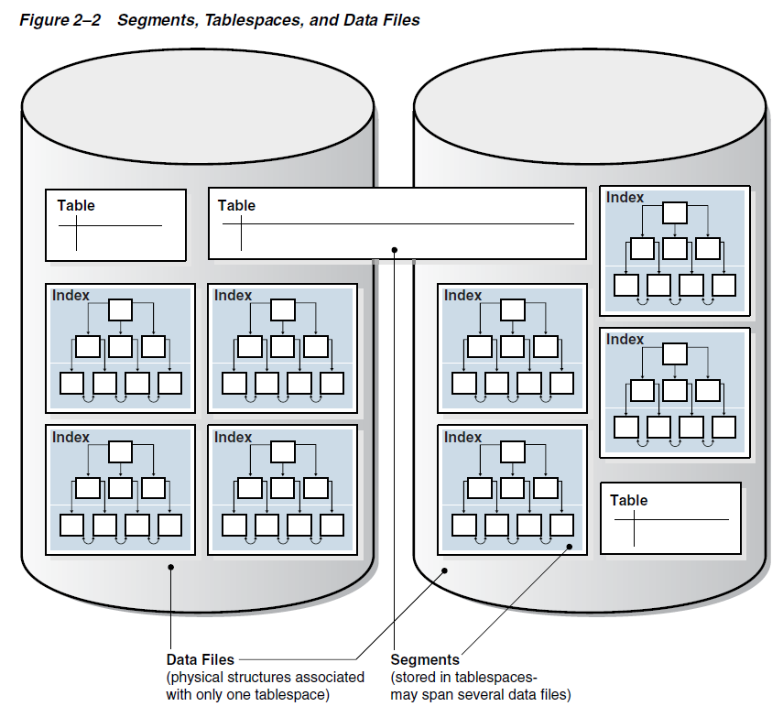

View
A view is a logical representation of one or more tables. In essence, a view is a stored query. A view derives its data from the tables on which it is based, called base tables. Base tables can be tables or other views. All operations performed on a view actually affect the base tables. You can use views in most places where tables are used.

Unlike a table, a view is not allocated storage space, nor does a view contain data. Rather, a view is defined by a query that extracts or derives data from the base tables referenced by the view. Because a view is based on other objects, it requires no storage other than storage for the query that defines the view in the data dictionary.

Sequence
A sequence is a schema object from which multiple users can generate unique integers. A sequence generator provides a highly scalable and well-performing method to generate surrogate keys for a number data type.

The sequence generator is useful in multiuser environments for generating unique numbers without the overhead of disk I/O or transaction locking. For example, two users simultaneously insert new rows into the orders table. By using a sequence to generate unique numbers for the order_id column, neither user has to wait for the other to enter the next available order number. The sequence automatically generates the correct values for each user.

Synonym
A synonym is an alias for a schema object. For example, you can create a synonym for a table or view, sequence, PL/SQL program unit, user-defined object type, or another synonym. Because a synonym is simply an alias, it requires no storage other than its definition in the data dictionary.
Synonyms can simplify SQL statements for database users. Synonyms are also useful for hiding the identity and location of an underlying schema object. If the underlying object must be renamed or moved, then only the synonym must be redefined. Applications based on the synonym continue to work without modification.

Data Dictionary
The data dictionary base tables are the first objects created in any Oracle database. All data dictionary tables and views for a database are stored in the SYSTEM tablespace. Because the SYSTEM tablespace is always online when the database is open, the data dictionary is always available when the database is open.

The Oracle Database user SYS owns all base tables and user-accessible views of the data dictionary. Data in the base tables of the data dictionary is necessary for Oracle Database to function.

During database operation, Oracle Database reads the data dictionary to ascertain that schema objects exist and that users have proper access to them. Oracle Database also updates the data dictionary continuously to reflect changes in database structures, auditing, grants, and data.
For example, if user hr creates a table named interns, then new rows are added to the data dictionary that reflect the new table, columns, segment, extents, and the privileges that hr has on the table. This new information is visible the next time the dictionary views are queried.
Oracle Database creates public synonyms for many data dictionary views so users can access them conveniently

Physical and Logical Storage

An Oracle database is a set of files that store Oracle data in persistent disk storage.
A data file is a physical file on disk that was created by Oracle Database and contains data structures such as tables and indexes. A temp file is a data file that belongs to a temporary tablespace. The data is written to these files in an Oracle proprietary format that cannot be read by other programs.

Oracle Database creates a data file for a tablespace by allocating the specified amount of disk space plus the overhead for the data file header.

When Oracle Database first creates a data file, the allocated disk space is formatted but contains no user data. However, the database reserves the space to hold the data for future segments of the associated tablespace. As the data grows in a tablespace, Oracle Database uses the free space in the data files to allocate extents for the segment.

The following figure illustrates the different types of space in a data file. Extents are either used, which means they contain segment data, or free, which means they are available for reuse. Over time, updates and deletions of objects within a tablespace can create pockets of empty space that individually are not large enough to be reused for new data. This type of empty space is called fragmented free space.
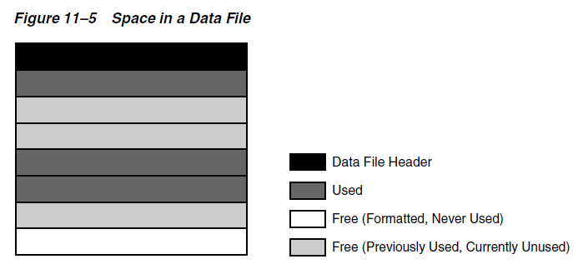

Oracle Database allocates logical space for all data in the database. The logical units of database space allocation are data blocks, extents, segments, and tablespaces. At a physical level, the data is stored in data files on disk. The data in the data files is stored in operating system blocks.
An operating system block is the minimum unit of data that the operating system can read or write. In contrast, an Oracle block is a logical storage structure whose size and structure are not known to the operating system.

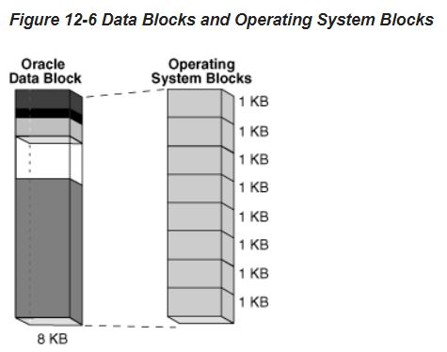

Figure 12–1 is an entity-relationship diagram for physical and logical storage. The crow's foot notation represents one-to-many relationship.

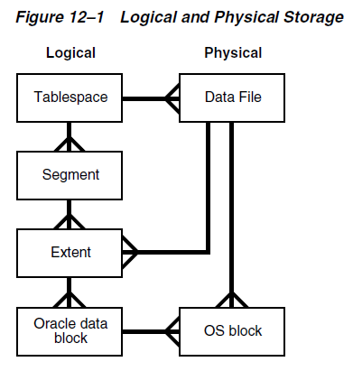

At the finest level of granularity, Oracle Database stores data in data blocks. One logical data block corresponds to a specific number of bytes of physical disk space, for example, 2 KB. Data blocks are the smallest units of storage that Oracle Database can use or allocate.
An extent is a set of logically contiguous data blocks allocated for storing a specific type of information.
A segment is a set of extents allocated for a specific database object, such as a table. For example, the data for the employees table is stored in its own data segment, whereas each index for employees is stored in its own index segment. Every database object that consumes storage consists of a single segment.

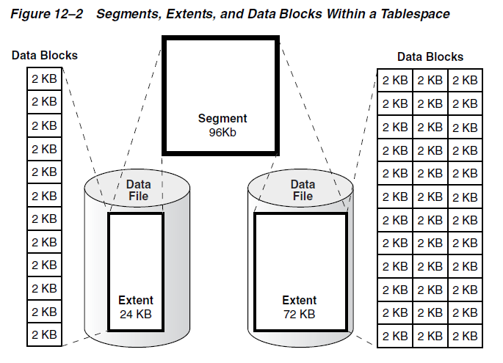

Logical Space Management
Oracle Database must use logical space management to track and allocate the extents in a tablespace. When a database object requires an extent, the database must have a method of finding and providing it. Similarly, when an object no longer requires an extent, the database must have a method of making the free extent available.
Oracle Database manages space within a tablespace based on the type that you create. You can create either of the following types of tablespaces:
- Locally managed tablespaces (default)
- Dictionary-managed tablespaces

A dictionary-managed tablespace uses the data dictionary to manage its extents.

A locally managed tablespace maintains a bitmap in the data file header to track free and used space in the data file body. Each bit corresponds to a group of blocks. When space is allocated or freed, Oracle Database changes the bitmap values to reflect the new status of the blocks.
Within a locally managed tablespace, the database can manage segments automatically or manually.

Automatic Segment Space Management (ASSM) avoids the need to manually determine correct settings for many storage parameters. Only one crucial SQL parameter controls space allocation: PCTFREE. This parameter specifies the percentage of space to be reserved in a block for future updates.

The legacy Manual Segment Space Management (MSSM) method uses a linked list called a free list to manage free space in the segment. In addition to PCTFREE, MSSM requires you to control space allocation with SQL parameters such as PCTUSED, FREELISTS, and FREELIST GROUPS.

Block size
Every database has a database block size. The DB_BLOCK_SIZE initialization parameter sets the data block size for a database when it is created. The size is set for the SYSTEM and SYSAUX tablespaces and is the default for all other tablespaces. The database block size cannot be changed except by re-creating the database.
You can create individual tablespaces whose block size differs from the DB_BLOCK_SIZE setting.

Oracle Database stores rows as variable-length records. A row is contained in one or more row pieces. Each row piece has a row header and column data.

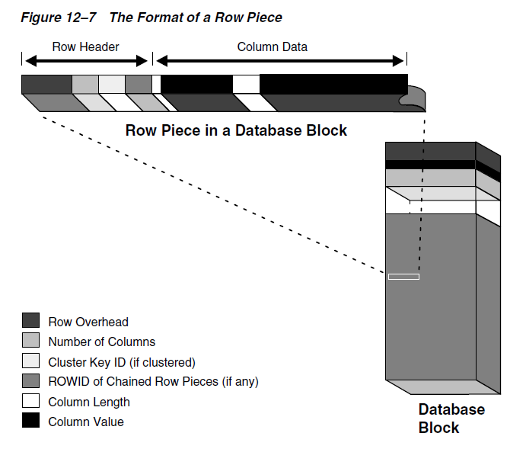

As the database fills a data block from the bottom up, the amount of free space between the row data and the block header decreases. This free space can also shrink during updates, as when changing a trailing null to a nonnull value. The database manages free space in the data block to optimize performance and avoid wasted space.
The PCTFREE storage parameter is essential to how the database manages free space. This SQL parameter sets the minimum percentage of a data block reserved as free space for updates to existing rows.

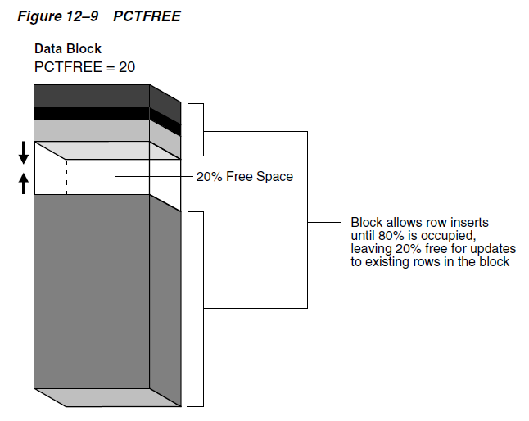

A single data segment in a database stores the data for one user object. There are different types of segments. Examples of user segments include:
Table, table partition, table cluster, LOB or LOB partition, Index or index partition.
By default, the database uses deferred segment creation to update only database metadata when creating tables and indexes. When a user inserts the first row into a table or partition, the database creates segments for the table or partition, its LOB columns, and its indexes.

