Oracle database concepts

One characteristic of an RDBMS is the independence of logical data structures such as tables, views, and indexes from physical storage structures.
Because physical and logical structures are separate, you can manage physical storage of data without affecting access to logical structures. For example, renaming a database file does not rename the tables stored in it.
A data file is a physical file on disk that was created by Oracle Database and contains data structures such as tables and indexes. A temp file is a data file that belongs to a temporary tablespace. The database writes data to these files in an Oracle proprietary format that cannot be read by other programs.
The database control file is a small binary file associated with only one database. Each database has one unique control file, although multiple identical copies are permitted. A control file contains information such as the following: the database name, information about data files, online redo log files, tablespace information, etc. The control file contains information required to recover the database, including checkpoints. A checkpoint indicates the SCN (System Change Number) in the redo stream where instance recovery would be required to begin.
The most crucial structure for recovery is the online redo log. The online redo log is a set of files containing records of changes made to data. The database maintains online redo log files to protect against data loss. Specifically, after an instance failure, the online redo log files enable Oracle Database to recover committed data that it has not yet written to the data files.
Server processes write every transaction synchronously to the redo log buffer, which the LGWR process then writes to the online redo log. Contents of the online redo log include uncommitted transactions, and schema and object management statements.

Log writer writes to online redo log files circularly. A log switch occurs when the database stops writing to one online redo log file and begins writing to another. Normally, a switch occurs when the current online redo log file is full and writing must continue.

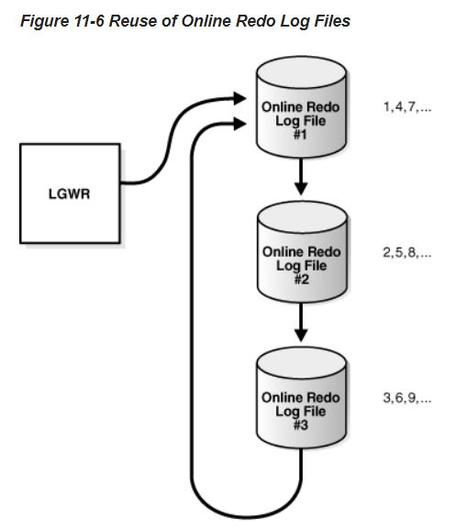

Most Oracle databases store files in a file system, which is a data structure built inside a contiguous disk address space. All operating systems have file managers that allocate and deallocate disk space into files within a file system. A file system enables disk space to be allocated to many files. Each file has a name and is made to appear as a contiguous address space to applications such as Oracle Database. The database can create, read, write, resize, and delete files.

Oracle Managed Files is a file naming strategy that enables you to specify operations in terms of database objects rather than file names. For example, you can create a tablespace without specifying the names of its data files.
With user-managed files, you directly manage the operating system files in the database. You make the decisions regarding file structure and naming. For example, when you create a tablespace you set the name and path of the tablespace data files.

Oracle Managed Files does not eliminate existing functionality. You can create new files while manually administering old files. Thus, a database can have a mixture of Oracle Managed Files and user-managed files.

At the operating system level, Oracle Database stores database data in structures called data files. Every Oracle database must have at least one data file.

A database must have the SYSTEM and SYSAUX tablespaces. Oracle Database automatically allocates the first data files of any database for the SYSTEM tablespace during database creation.
The SYSTEM tablespace contains the data dictionary, a set of tables that contains database metadata. Typically, a database also has an undo tablespace and a temporary tablespace (usually named TEMP).

A permanent tablespace contains persistent schema objects. Objects in permanent tablespaces are stored in data files
A temporary tablespace contains schema objects only for the duration of a session. Locally managed temporary tablespaces have temporary files (temp files), which are special files designed to store data in hash, sort, and other operations. Temp files also store result set data when insufficient space exists in memory.

When Oracle Database first creates a data file, the allocated disk space is formatted but contains no user data. However, the database reserves the space to hold the data for future segments of the associated tablespace. As the data grows in a tablespace, Oracle Database uses the free space in the data files to allocate extents for the segment.

