**Dynamic CORBA, Part 1: The Dynamic Invocation Interface**

(Page [1](http://www.ddj.com/cpp/184403833?pgno=1) of [2](http://www.ddj.com/cpp/184403833?pgno=2))

*Douglas C. Schmidt*

An important and growing class of applications requires the flexibility provided by Dynamic CORBA features. This column covers the basics of the CORBA DII, which is the client-side interface used for dynamic CORBA applications.

**Figure 1: Compiling an IDL file**

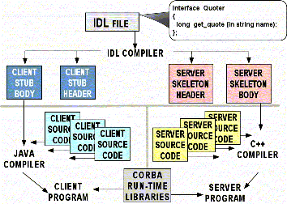

1 | [2](http://www.ddj.com/cpp/184403833?pgno=2) [Next Page](http://www.ddj.com/cpp/184403833?pgno=2) http://i.cmpnet.com/ddj/redarrow.gif